OS Assignment-04

Jeetu Mehra
U24AI032

Question 1 : Perform Following
a) Obtain a listing of processes by using the ps command.
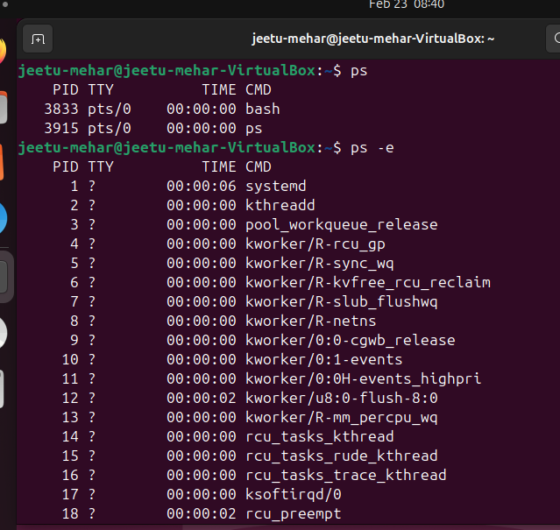

b) Use a Linux command which displays a tree of all processes in the system.
Code:
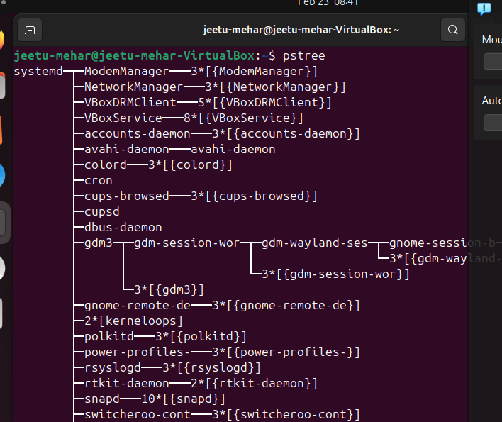

c) Use Exec(), Wait() and Exit() system call.
Code:

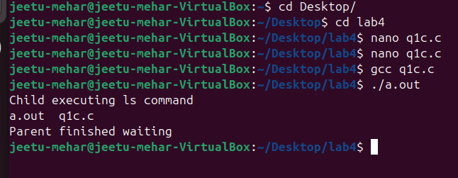

d) Start a browser and check the process ID of the browser using Top command
Code:
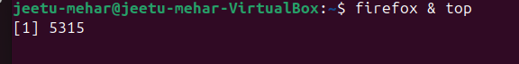
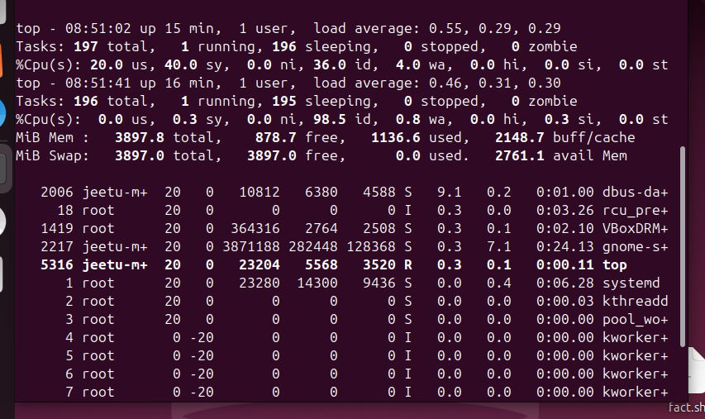

e) Kill the browser process using “kill” command
Code:
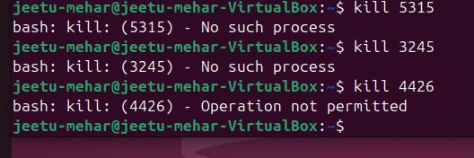

f) Change the priority of any user process by using “nice” command
Code:

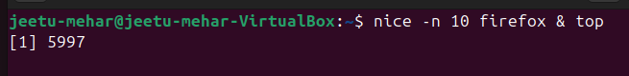
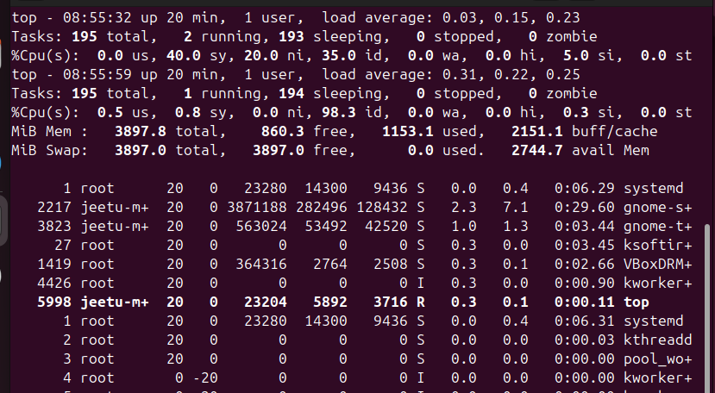

Question 2 : Write a C program using the fork() system call that generates this sequence in the child process.
The starting number will be provided from the user. For example, if 8 is passed as a parameter
on the command line, the child process will output 8, 4, 2, 1. Because the parent and child
processes have their own copies of the data, it will be necessary for the child to output the
sequence. Parent invoke the wait() call to wait for the child process to complete before exiting
the program. Ensure that a positive integer is passed on the command line.
Code:
#include <stdio.h>
#include <stdlib.h>
#include <unistd.h>
#include <sys/wait.h>

int main(int argc, char *argv[]) {

// Check command line argument
if(argc != 2) {
printf("Usage: ./a.out <positive_integer>\n");
return 1;
}

int n = atoi(argv[1]);

// Check if positive
if(n <= 0) {
printf("Please enter a positive integer.\n");
return 1;
}

pid_t pid = fork();

if(pid < 0) {
printf("Fork failed.\n");
return 1;
}

if(pid == 0) {
// Child process
printf("Child Process Output:\n");

while(n > 0) {
printf("%d ", n);
n = n / 2;
}

printf("\n");
exit(0);
}
else {
// Parent process
wait(NULL); // Wait for child to finish
printf("Parent: Child has completed execution.\n");
}
return 0;
}

}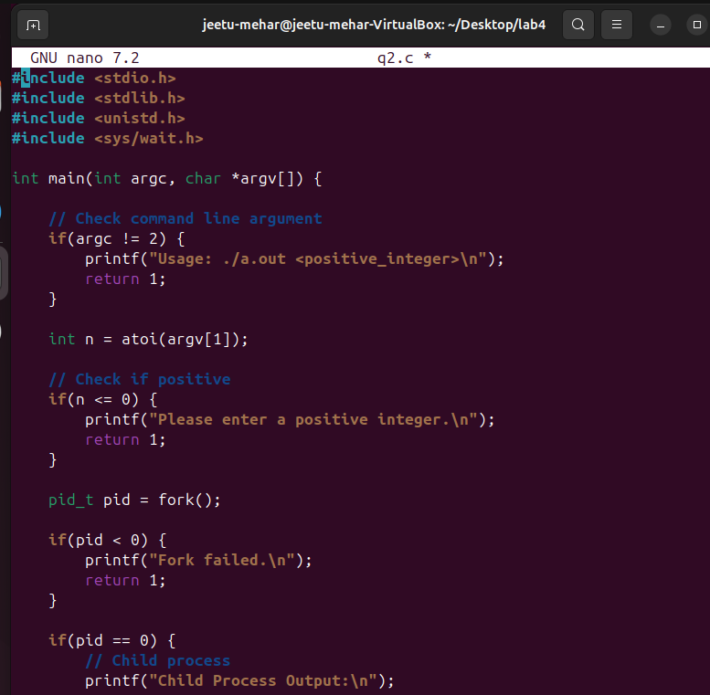
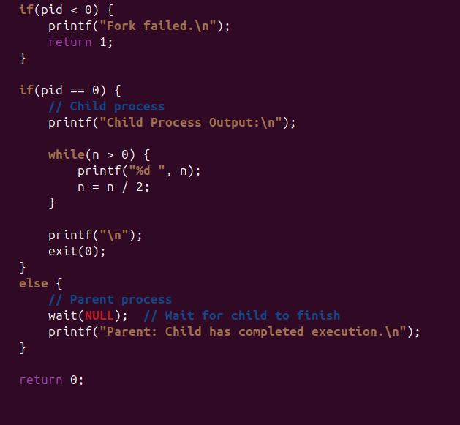
Output:
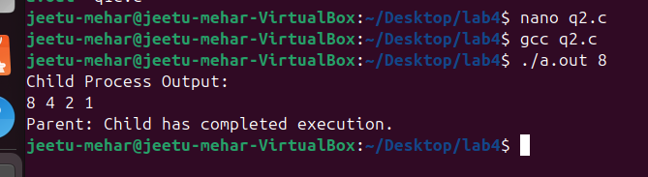

Question 3 : Check output and Reason for it.
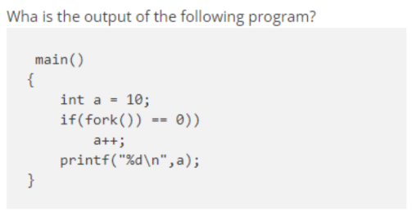
(1)

Output:
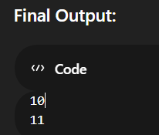

(2)
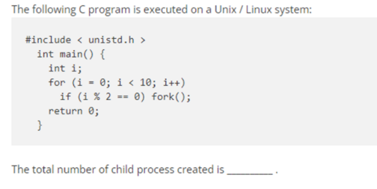

Output:

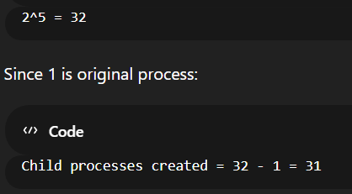

Question 4 : What happens if parent is killed (status of child), what happens when child is killed, what
happens when terminal is killed (). Try these in different sequences - parent, terminal; child
terminal; terminal parent etc.
- What happens if Parent Process is killed?

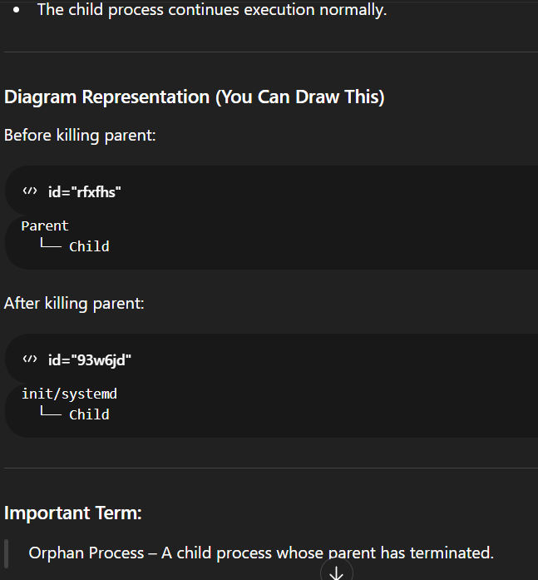

- What happens if Child Process is killed?
Parent process continues execution normally.


- What happens if Terminal is killed?
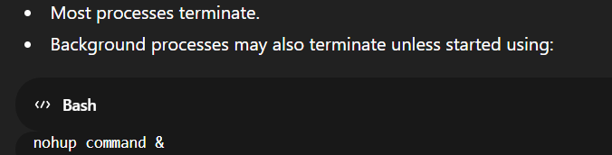

Question 5 : Write a shell program to search for a given number from the list of numbers using
binary search.

1️⃣ exec()
- Replaces current process with a new program.
- PID remains same.
- Old code and data are removed.

2️⃣ wait()
- Parent waits for child to finish.
- Prevents zombie process.

3️⃣ yield()
- Gives CPU to another ready process.
- Used in scheduling.

4️⃣ sleep()
- Suspends process for given seconds.
- After time, process resumes.

B ) Verify whether local, global, and static variables are shared between parent and child
processes.
c) Verify the parent of a parent process.
CODE:
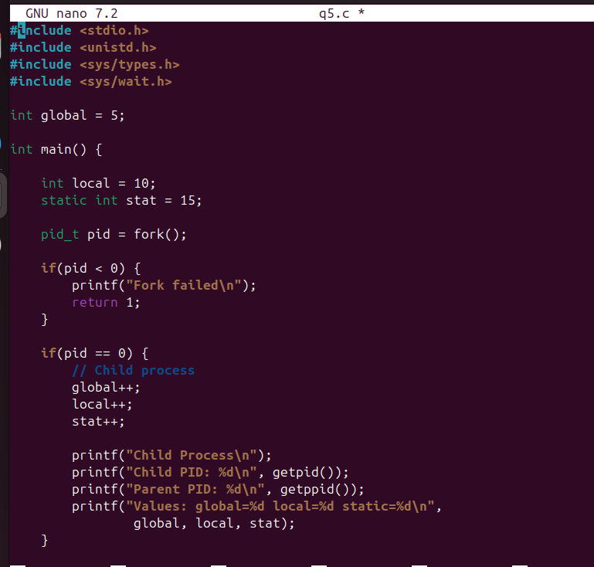
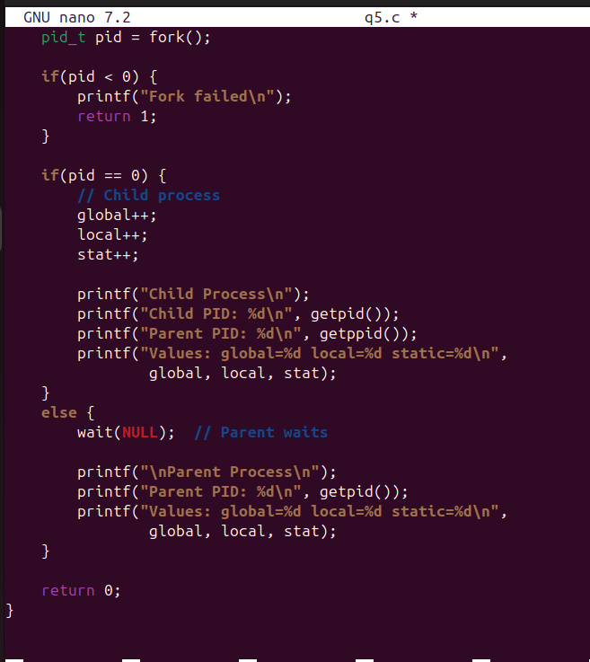

OUTPUT:
